**HO CHI MINH NATIONAL UNIVERSITY**

**UNIVERSITY OF INFORMATION TECHNOLOGY**

**INFORMATION SYTEM DEPARTMENT**



**Cloud Computing**

**MSIS402.O12.CTTT**

**FINAL REPORT**

**Amazon Web Services**

**INSTRUCTOR: PHAN XUAN THIEN**

**Group: 3**

Nguyễn Minh Thành-20521920

Nguyễn Văn Tân-20521880

Quách Vinh Quang-20521811

Lê Văn Sỹ - 20521854

Contents

CHAPTER 1: Cloud computing overview 2

I. Overview 2

II. Define 3

III. Solutions 4

IV. Features of Cloud Computing 5

V. Difficulties and challenges 6

VI. Development trends 7

CHAPTER 2: Reality of Cloud Computing 8

I. Reality of cloud computing 8

II. Compare IaaS , PaaS and SaaS 12

Chapter 3. Amazon Web Service 14

I. What is AWS? 14

II. How Does AWS Work? 14

III. Availability 14

IV. Services 15

V. Service Configuration 16

A. EC2 16

B. VPC 28

C. S3 31

D. DynamoDB 37

E. KMS 40

# CHAPTER 1: Cloud computing overview

1. Overview

"Cloud Computing" is a relatively new notion to us in recent years. It has a large number of applications that are linked to the Internet. Because the network is a virtual environment, data is the most important concern for the apps that run on it. Processing, storing, securing, and managing data is not easy; it necessitates significant investments in hardware, software, networks, staffing, maintenance, and upgrades, among other things. When organizations and companies employ Cloud Computing services, they are quite concerned about this issue, yet cloud computing technology assists them in reducing costs for establishing, developing, and maintaining applications. So all they have to do now is concentrate on their business. Many large organizations are currently making significant investments in cloud computing systems such as Microsoft, IBM, Google,...

1. Define

Cloud Computing, also known as virtual server computing, is a computing model that uses computer technologies and develops based on the internet. The term "cloud" here refers to the Internet. In this cloud computing model, all IT-related capabilities are provided as a service, allowing users to access technology services from a certain provider in the cloud. without having knowledge and experience of that technology

According to Wikipedia:

“Cloud computing is a scalable computing model(scalable) is flexible and  
resources are usually virtualized provided as a service on the Internet”.

According to the American Institute of Standards and Technology (NIST), cloud computing is defined as follows:

"Cloud Computing is a service model that allows people to access shared computing resources (networks, servers, storage, applications, services) through network connections easily, anytime, anywhere, according to their needs. Cloud resources can be quickly set up or canceled by the user without the intervention of the Service Provider".

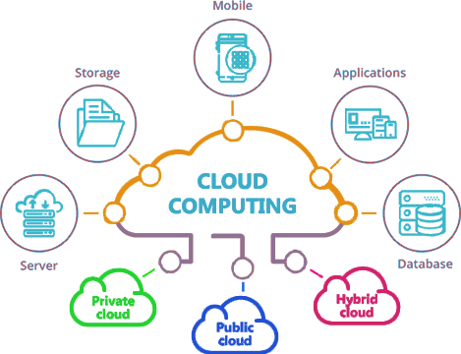Figure 1: It's all in the cloud.

1. Solutions

Cloud Computing was created to address the following issues:

● Data storage issue:

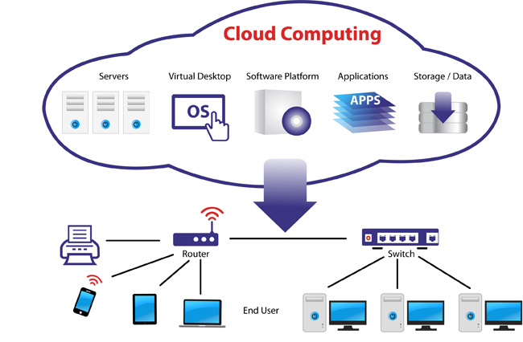Data is centralized in massive data warehouses. Microsoft and Google, for example, have hundreds of major data warehouses around the world. These huge corporations will offer services that enable organizations to store and manage data in centralized repositories.

Figure 2: Overview model of cloud computing

● The problem of computing power:

There are two basic solutions:

o Using super-computers to handle calculations.

o Using parallel, distributed, and grid computing systems.

● Problems with providing resources and software include the following:

Provide services such as IaaS (infrastructure as a service), PaaS (platform as a service), and SaaS (software as a service).

1. Features of Cloud Computing

*1 – Self-service on demand*

Cloud computing's technical qualities allow customers to define resource requirements unilaterally to meet system requirements such as server usage time, storage capacity, and the ability to fulfill specific requirements, as well as a high amount of system interaction with the outside world.

*2 – Wide Area Access*

Customers just need to be connected to the Internet to use cloud computing services because they run on the Internet. Mobile phones, laptops, and PDAs are examples of information retrieval devices that do not require a lot of configuration (thin or thick client platforms).

*3 – Resource sharing and location independence*

The resources of service providers are pooled to serve several users in a "multi-tenant" model. This architecture enables for dynamic allocation of hardware and virtualization resources based on user requirements. When demand from users drops or rises, resources will be requisitioned to meet the need.

*4 – The ability to quickly stretch*

This capability enables the system to automatically grow or contract in response to the user's needs. As demand grows, the system extends automatically by adding resources. When demand falls, the system will cut resources automatically.

Elasticity allows suppliers to make optimal use of resources, make full use of redundant resources, and serve a large number of clients. Scalability helps service consumers save money because they only pay for the resources they really utilize.

*5 – Pay according to actual use*

Many cloud services use an on-demand computing model, which is similar to how traditional on-demand utilities such as electricity are consumed, while others market on a down payment basis. Cloud computing allows to limit storage, bandwidth, computing resources and number of active users per month.

1. Difficulties and challenges

In the process of implementing cloud computing, people realize a number of difficulties and challenges

following formula:

● Security

o Intellectual property

o Privacy

o Reliability

● Possibility of not controlling data

● Data Latency

● Availability of services, data

● Additional services

● Legal requirements for services, between customers and suppliers.

1. Development trends

The term "cloud computing" was coined in mid-2007, and it has since been heavily developed and deployed by several major corporations around the world, including IBM, Sun, Amazon, Google, Microsoft, Yahoo, Sales Force, and others.

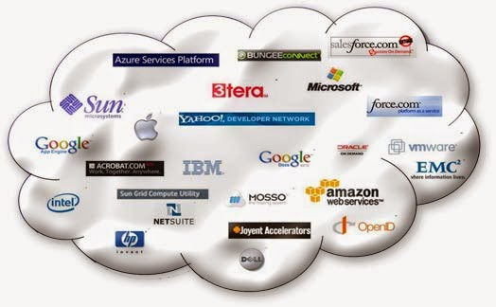

Figure 3: Some companies offer cloud computing services.

Cloud computing has been and continues to generate tremendous profits, giving a playground, and a vast market for suppliers, with the purpose of solving problems in data, computers, services, and so on for consumers. Its rapid expansion can be measured by the day. Meanwhile, because the original phrase "grid computing" isn't economically viable or profitable, it's popularity is waning, and it's now exclusively used in scientific study.

# CHAPTER 2: Reality of Cloud Computing

1. Reality of cloud computing

Cloud computing offers infrastructure, platforms, and software as a service to users, which can be rented on a pay-as-you-go basis.

Cloud service providers offer their services under three basic models:

o Services for Infrastructure (IaaS – Infrastructure as a Service).

o Platform as a Service (PaaS – Platform as a Service).

o Service for Software (SaaS – Software as a Service).

***Services for Infrastructure (IaaS – Infrastructure as a Service).***

Application developers give consumers with a virtual area to store and build services in IaaS cloud, which is regarded a sort of development service that is best invested in cloud computing technology.

We can rent and use computer network hardware through Infrastructure as a Service (IaaS).

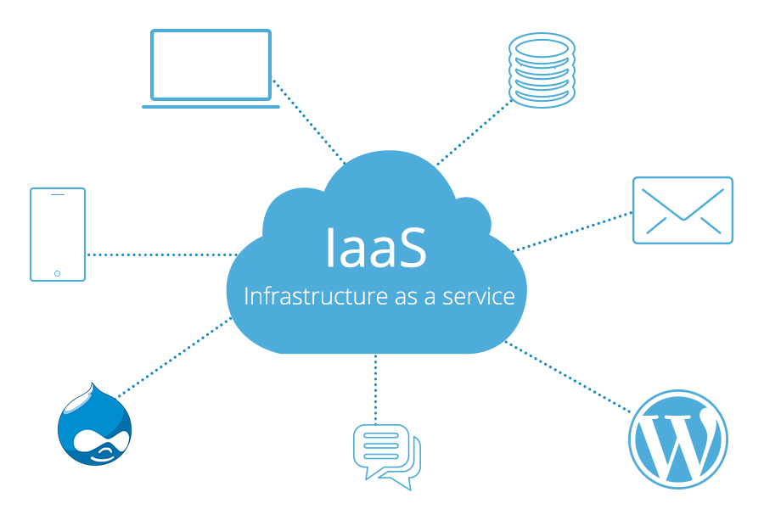IaaS provides various resources such as firewalls, load balancers, and IP addresses, but the user must install and maintain the operating system and applications. This allows for more flexibility in the allocation of resources.

Amazon, Google, and Windows vendors all offer IaaS.... Developing templates for cloud

Figure 4: Infrastructure as a service

services to generate a blueprint for building a ready-to-use system and prevent migrating across different clouds is one technique to make IaaS management easier.

Workstations can hire full external services rather of purchasing them, such as a rental server, consolidated storage space, or network equipment. These services are usually invoiced on a per-function basis, with the quantity of resources consumed (and thus the price) reflecting the level of activity.

**Notable features:**

- Provide resources as a service: including servers, network equipment, memory, CPU, hard disk space, data center equipment.

- Flexible scalability

- Costs vary depending on reality

- Many tenants can share the same resource

- Enterprise level: benefit the company by a pool of computational resources

***Platform as a Service (PaaS – Platform as a Service).***

Customers can use the PaaS service to design, test, and deploy cloud-based applications using a set of tools. An organizational unit, an enterprise, or a third party can use the developed application inside or provide it to them outside. ISVs (Independent Software Vendors), which design software programs and deliver services to end-user clients, are typical PaaS customers.

Because cloud computing services that distribute applications over the Internet are unique, most PaaS platforms include toolkits for developing Web-based apps. Major PaaS services today enable application development on popular application development languages and platforms such as.NET (Microsoft Windows Azure), Java, Python, Ruby (Google App Engine, Amazon), and others.

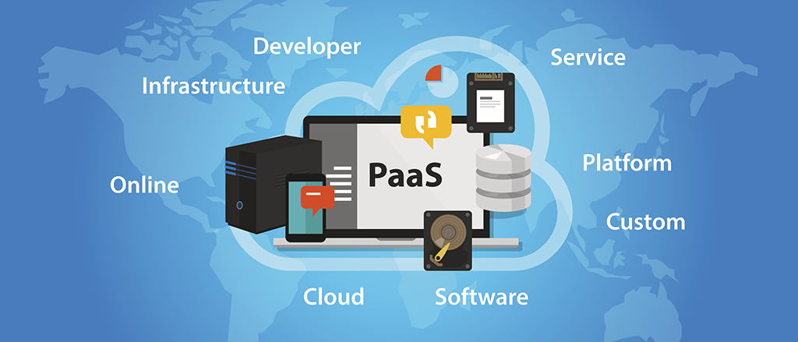

Figure 5: Flatform as a service

**Notable features:**

- Act as an integrated development environment for developing, testing, deploying, and operating the application.

- Web-based interface for initialization tools.

- Database and web service integration

- Encourage collaboration among development teams

***Service for Software (SaaS – Software as a Service).***

Software as a Service (SaaS) is the best choice when we want to focus on the end user. Gives us access to cloud-based software without managing the infrastructure and platform it's running. Before cloud computing was widely exchanged in the IT world today, software services (SaaS) appeared for a long time, the most popular are email services such as hotmail, yahoo mail, gmail ...

These services also provide organizations with email services with their own domain names for a relatively inexpensive fee. SaaS software services for businesses are growing more recently: for example, Microsoft's Office 365 office application services with email, collaboration, internal communication applications; customer management (CRM) applications of SalesForce, e-commerce applications of Amazon ... SaaS application services bring organizations and businesses many benefits. The unit pays a weekly and monthly usage cost without paying the full license fee at the beginning. The budget of the business does not have to shoulder a large initial investment but will pay off gradually and increase when the need really arises. In addition, organizations and businesses also have the advantage of trying and choosing the right SaaS software, minimizing costs.

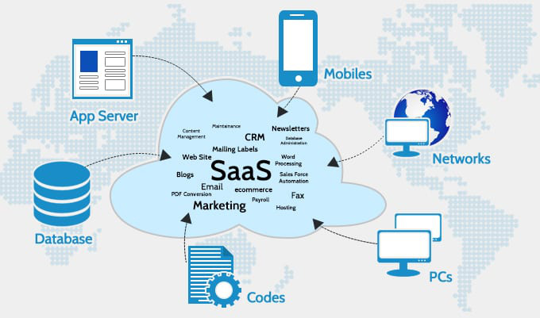SaaS providers can host the application on their servers or download it to the client device, disabling it after the end of the term. The 12 on-demand functions can be controlled internally to share the license of a third party application provider

Figure 6: Software as a service

**Notable features**:

- Available software requires network access and management.

- Manage operations from a centralized location rather than at the customer's location, allowing customers to access it remotely via the web. Provides common applications close to one or more mapping models including architecture, pricing, and management features.

- Features focus on upgrades, saving users from downloading patches and updates.

- Regularly integrate communication software on wide area network.

1. Compare IaaS , PaaS and SaaS

**IaaS (Infrastructure as a service)**

Characteristics:

○ Remote management

○ Stored on a server, data safe

○ Accessible via the internet

○ The user is not responsible for software or hardware updates.

Advantages:

○ Reduce time spent installing applications, managing and upgrading software.

○ Helping businesses focus more on business than on system management and handling issues.

Suitable for:

○ Small startups, need to run website services to market quickly.

○ Suitable for short-term projects that need collaborators to work remotely.

○ Infrequently accessed applications such as tax software, ..

○ Suitable for web and mobile apps

For example:

○ Google Apps, Dropbox, Salesforce, Cisco WebEx, Concur, GoToMeeting.

**PaaS (Platform as a service)**

Characteristics:

○ Built on virtualization technology, which means resource usage can easily be increased or decreased as needs change

○ Provides a variety of services to support application development, testing, and deployment.

○ Multiple users can access the same development application

○ Web services and databases are integrated.

Advantages:

○ The environment supports many different languages: Node.js, Java, Ruby, C#, Go, Python, or PHP depending on the cloud solution provider.

○ Can be easily extended

○ Flexible use for libraries, frameworks.

Suitable for:

○ Tech startups need to build systems and scale quickly.

○ Software businesses need to develop applications that are fast and easy to scale.

For example:

○ Google App Engine, Elastic Beanstalk – Amazon, Cloud Services – Azure, Openshift,…

**SaaS (Software as a service)**

Characteristics:

○ Resources available as a service

○ Prices vary depending on usage

○ Highly scalable service

○ Provide full control over the infrastructure for organizations

○ Dynamic and flexible cloud-based.

Advantages:

○ Easily enable automated deployment.

○ Give customers full control over their infrastructure.

○ Can buy resources when needed

○ High scalability.

Suitable for:

○ Startup or a small company, IaaS is an option so you don't have to spend time or money trying to create hardware

○ IaaS is also beneficial for large organizations that want full control over their applications and infrastructure.

○ Companies have very different computing power needs.

For example:

○ Digital Ocean, Linode, Compute Engine - Google, Amazon EC2, Azure Virtual Machine

○ To summarize, we can encapsulate services in the following model:

# Chapter 3. Amazon Web Service

Before we get into the details of AWS, we'll talk about the reasons why we chose it for this project: Most functionality, Largest community of customers and partners, Most secure, Fastest pace of innovation, Most proven operational expertise

1. What is AWS?

Amazon Web Services offers a global range of cloud-based products including compute, storage, database, analytics, networking, mobility, developer tools, management tools, IoT, security applications, and enterprise apps. These services help businesses grow faster, reduce IT costs, and scale. AWS products that the largest enterprises and best-known startups rely on to support their diverse workloads include: web and mobile applications, game development, data processing and warehousing, storage, etc Backups and more

1. How Does AWS Work?

AWS usually works in several different configurations depending on the user's requirements. However, the user must be able to see the type of configuration used and the particular server map with respect to the AWS service.

1. Availability

AWS provides services from dozens of data centers spread across 87 availability zones (AZs) in regions across the world. An AZ is a location that contains multiple physical data centers. A region is a collection of AZs in geographic proximity connected by low-latency network links.

A business will choose one or multiple AZs for a variety of reasons, such as compliance, proximity to end customers and availability optimization. For example, an AWS customer can spin up virtual machines (VMs) and replicate data in different AZs to achieve a highly reliable cloud infrastructure that is resistant to failures of individual servers or an entire data center.

1. Services
2. EC2

Amazon Elastic Compute Cloud (EC2) is a service that provides virtual servers – called EC2 instances -- for compute capacity. The EC2 service offers dozens of instance types with varying capacities and sizes. These are tailored to specific workload types and applications, such as memory-intensive and accelerated-computing jobs. AWS also provides Auto Scaling, a tool to dynamically scale capacity to maintain instance health and performance.

1. VPC

A virtual machine cloud (VPC) is a service that lets you launch AWS resources in a logically isolated virtual network that you define. It can be customized VPC by choosing own IP address range, creating subnets, and configuring route tables.

1. S3

Amazon Simple Storage Service (S3) provides scalable object storage for data backup, collection and analytics. An IT professional stores data and files as S3 objects -- which can range up to five gigabytes – inside S3 buckets to keep them organized. A business can save money with S3 through its Infrequent Access storage class or by using Amazon Glacier for long-term cold storage.

1. DynamoDB

Amazon DynamoDB is a fully managed, serverless, key-value NoSQL database designed to run high-performance applications at any scale. It offers builts-in security, encryption, backup, replication, caching, and integration with AWS services and tools.

1. KMS

Amazon Key Management Service (AWS KMS) is a fully managed service that makes it easy for you to create and control the cryptographic keys used to encrypt data. It provides a highly available key storage, management, and auditing solution to enencrypt data within applications and control the cryptographic keys used to decrypt that data.

1. Service Configuration
2. EC2
3. Launch an instance

Go into EC2 console and click Launch instance

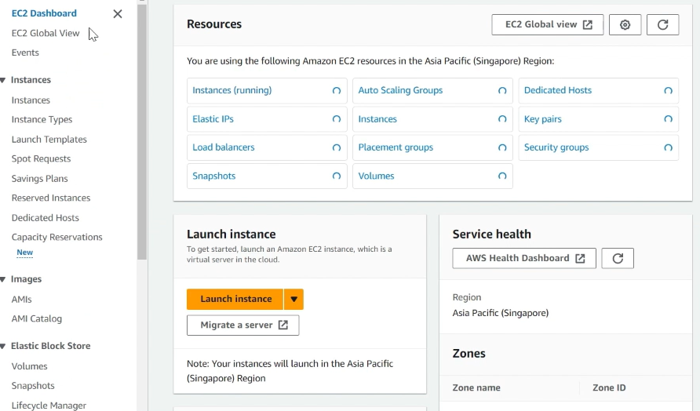

Enter name

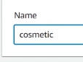

In selecting OS part, choose Ubuntu Server 22.04 LTS (free tier eligible version).

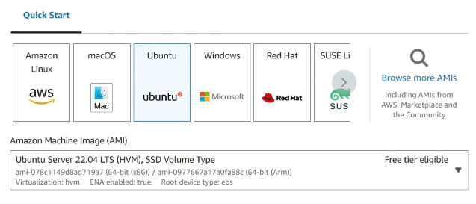

In key pair part, click create new key pair

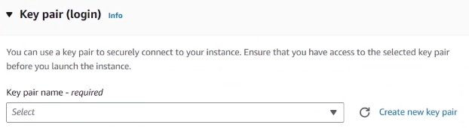

Enter key pair name then click Create key pair

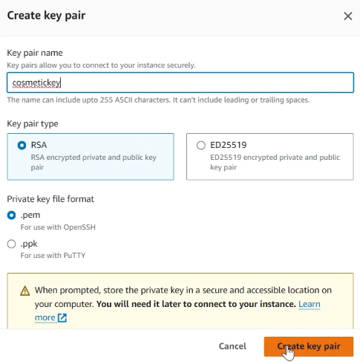

In configure storage part, increase root volume to 12 Gb, after that, click Launch instance

|  |  |
| --- | --- |
|  |  |

1. Use Xshell and Xftp to host web server (back-end)

Download Xshell and Xftp [in here](https://www.netsarang.com/en/free-for-home-school/), setup both and open them.

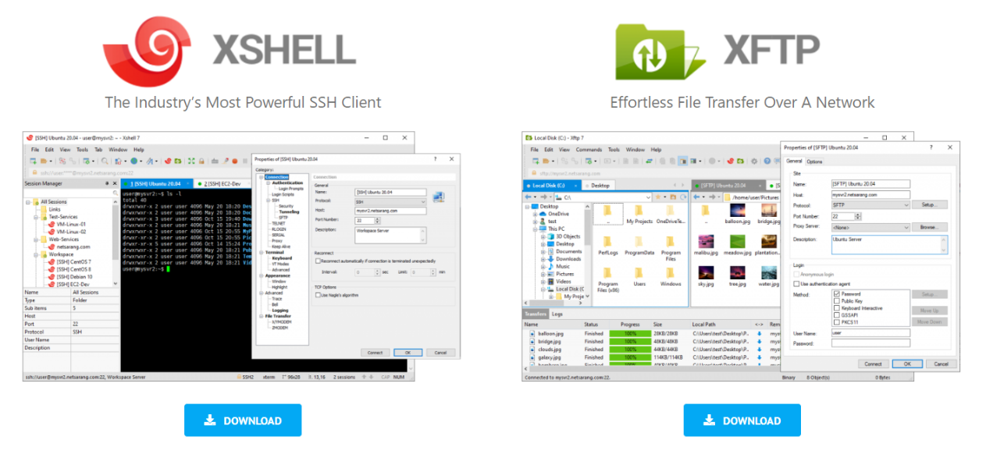

In Xshell, click on the icon on the top left to create new session.

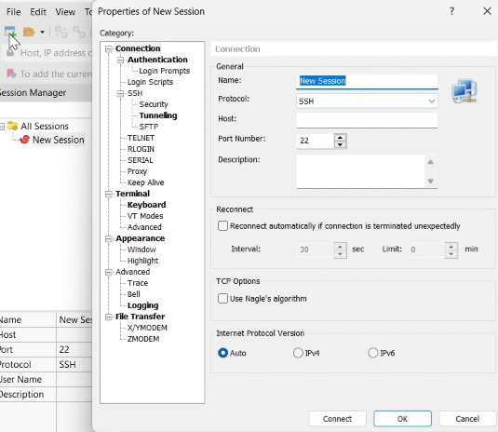

Enter name and host, the host name is the Public IPv4 address of an instance. To have the IPv4 address, in the EC2 console, navigate to Instance, click on the instance then Details.

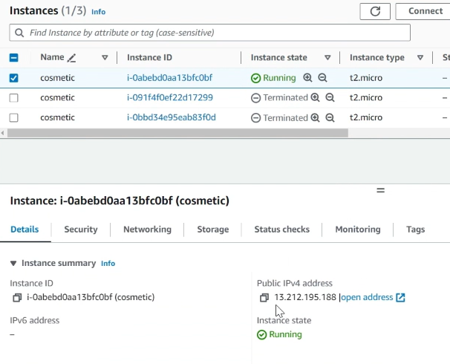

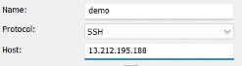

Click Authentication, enter name then tick on Public key and untick Password, after that, click Setup

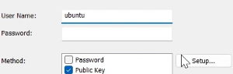

Click Browse, then click Import, choose the key pair, which is file .pem, created during Launch an instance process, then click Ok to save.

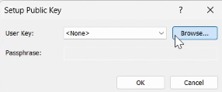

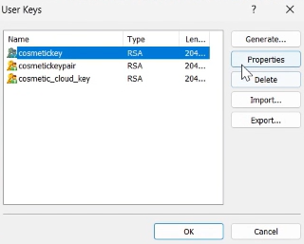



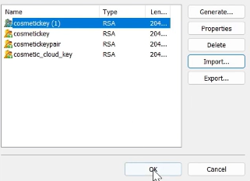

Click Ok again.

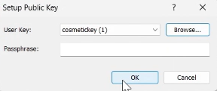

After configuring the property, click Connect.

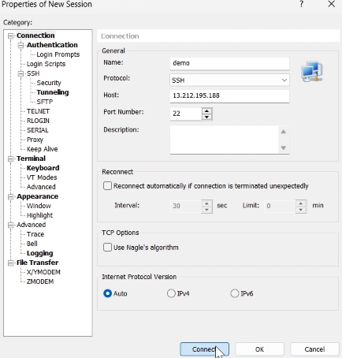

If the SSH Security Warning pop up, click Accept and Save.

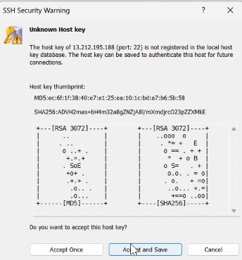

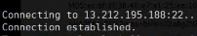



In Xftp, click on the icon on the top left, then enter host (Public IPv4 address).

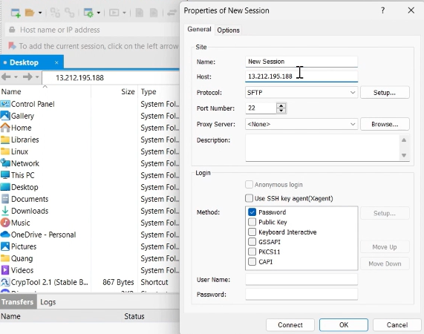

Enter username (created in xshell) then click ok.

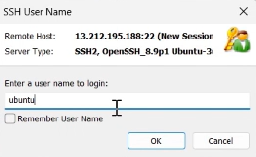

Choose the pair key created in Launch an instance session, then click Ok.

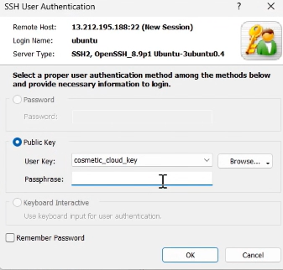

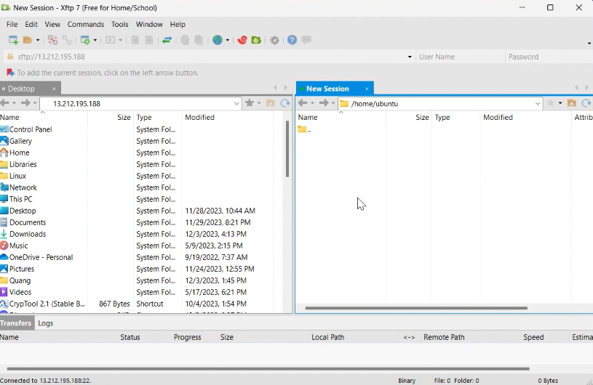

On left side, navigate to your backend folders/files, copy and paste all backend folders/files to the right side.

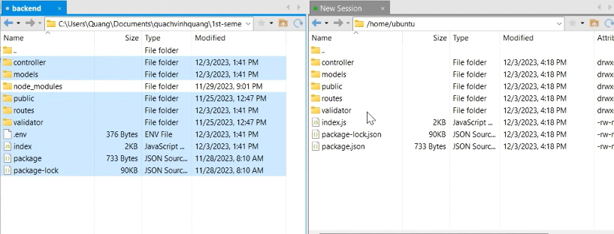

Use cd /home/<username> and then ls to check if all the files in directory.

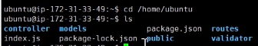

Install Nodejs in Ubuntu [in here](https://deb.nodesource.com/).

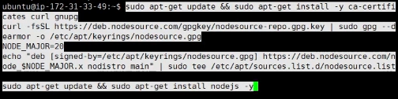

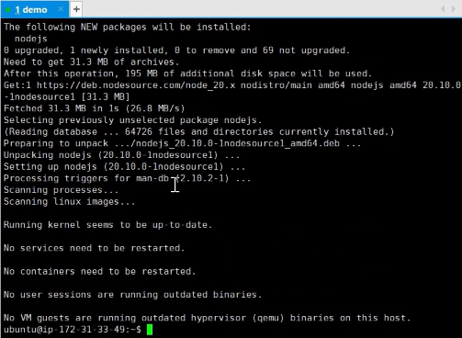

Use npm I to install necessary package



While waiting, go to EC2 console, navigate to Security and click on Security group id.

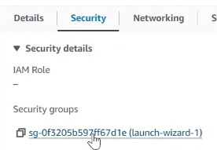

Click Edit inbound rules.

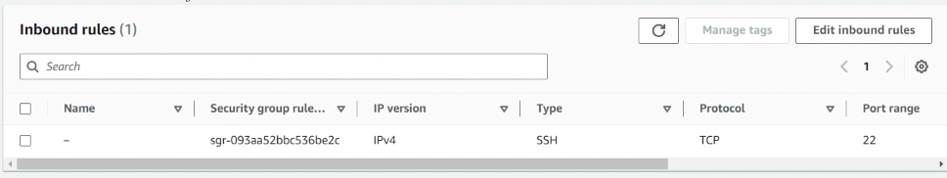

Click Add rule,

* On type, choose Custom TCP.
* On port range, set it to be your server port (in .env file).
* On Source, choose Anywhere and 0.0.0.0/0.

After that, click Save rules.

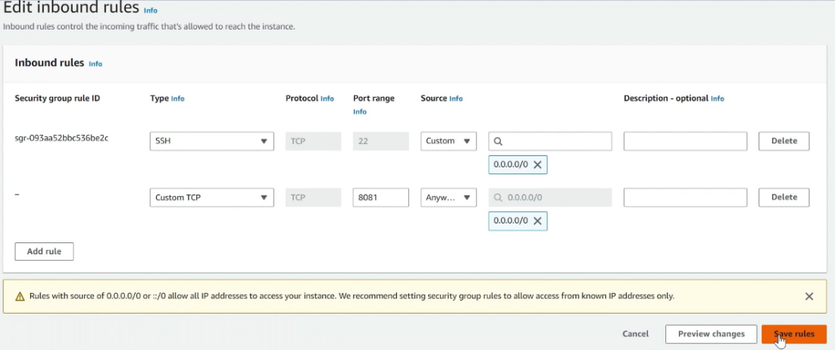

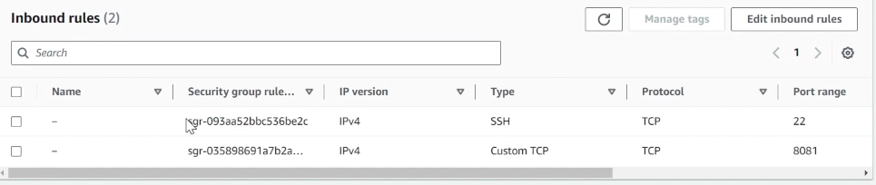

In Xshell, use npm start to start your server.

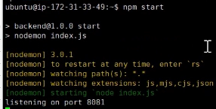

1. Test API

Note:

*Image file is stored in S3.*

*Database to store data in backend is DynamoDB.*

Open Postman, then:

* Choose HTTP methods.
* Change the URL hostname to be your instance’s public IPv4 address. Your server format should be http://<hostname>:<port>
* Choose one of your server’s API you want to test then paste it after the port. Example: If you want to test getAllUser, simply change the URL to be http://<hostname>:<port>/users/get

After that, click Send.

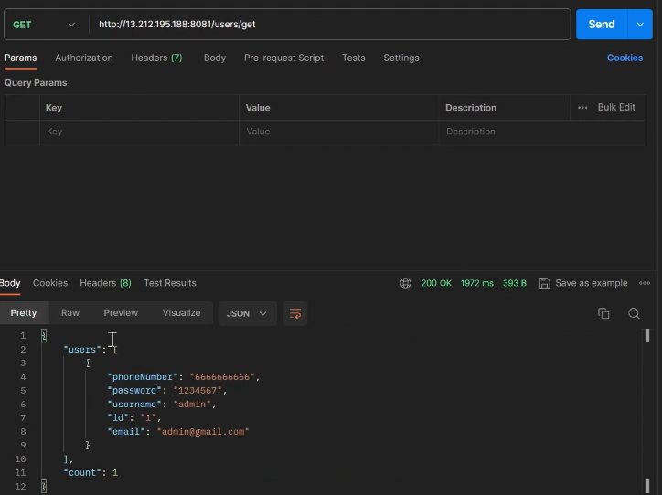

1. VPC

Go to VPC console, then click Create VPC.

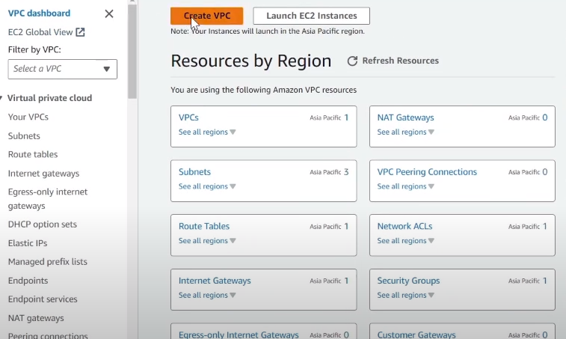

Click VPC and more.

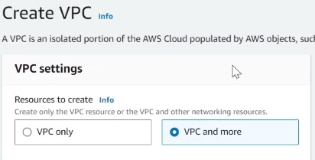

Configure your IPv4 CIDR block (you can modify based on your requirements).

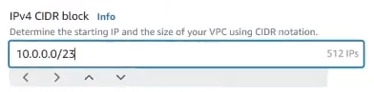

Configure AZ (you can modify based on your requirements).

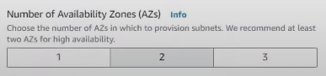

Configure subnets (you can modify based on your requirements).

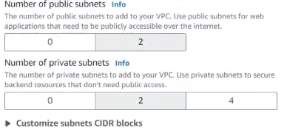

(Optional) Configure NATs gateway.

After that, click Create VPC.

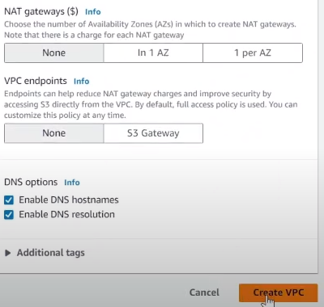

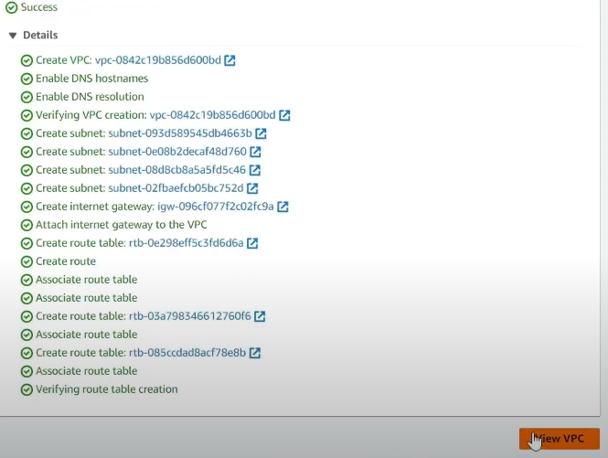

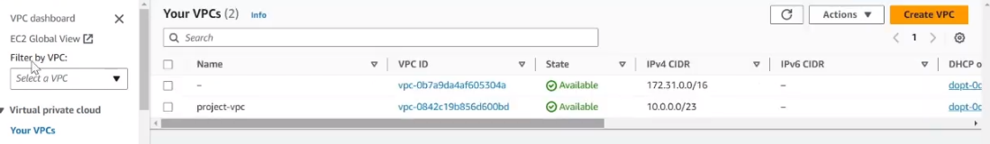

1. S3

1. Create a bucket

Go to the S3 console and lick “Create bucket”

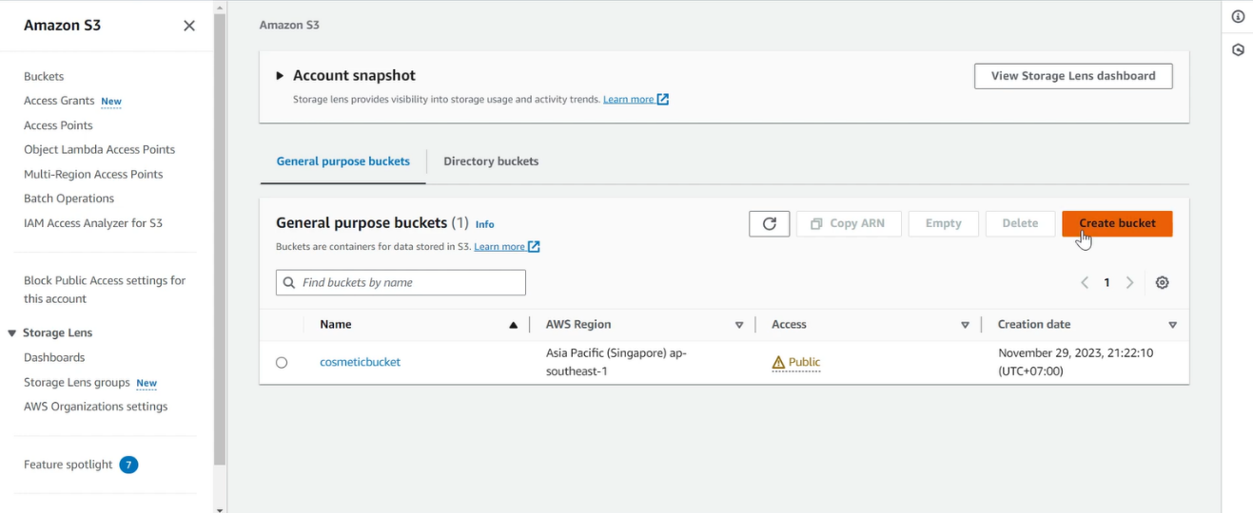

Enter bucket name

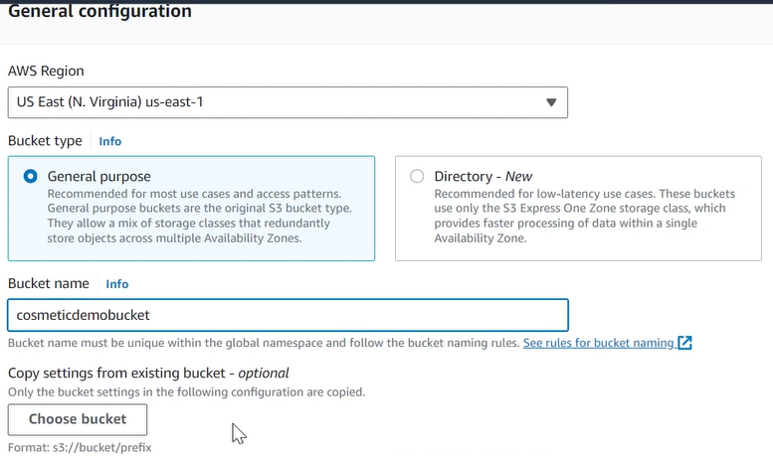

Turn off “Block all public access”

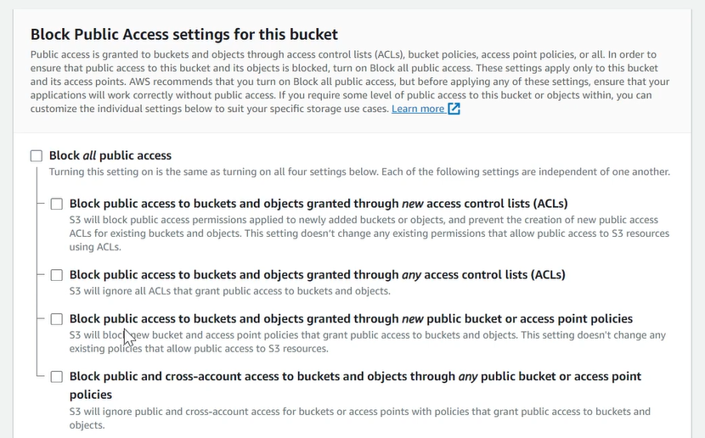

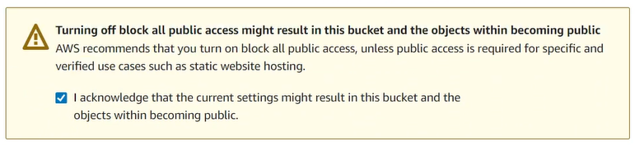

After that, click “Create Bucket”

2. Configure bucket’s permission

After creating bucket, click on the bucket and then navigate to Permission tab

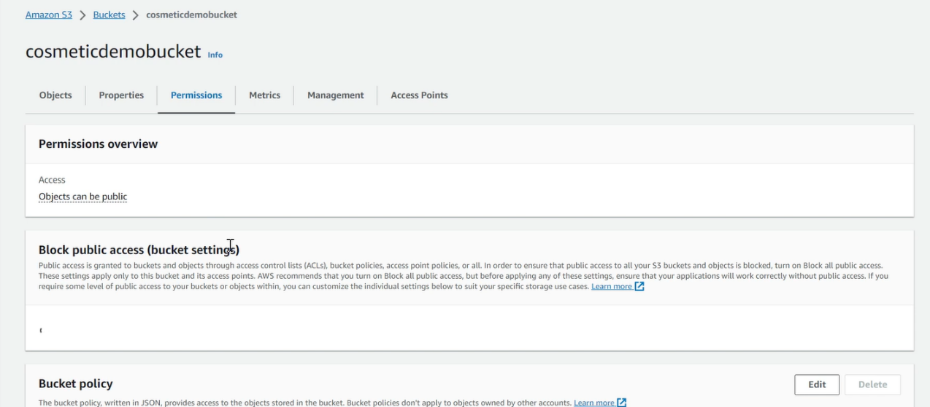

Scroll down to the Bucket policy part and then click Edit

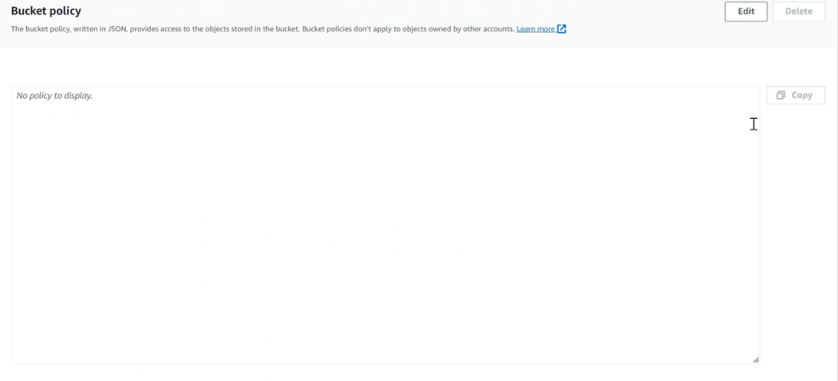

Edit the policy (the policy appears in JSON form) then click save changes

|  |
| --- |
| {  "Version": "2012-10-17",  "Statement": [  {  "Effect": "Allow",  "Principal": "*",  "Action": "s3:GetObject",  "Resource": "arn:aws:s3:::cosmeticdemobucket/*"  }  ]  } |

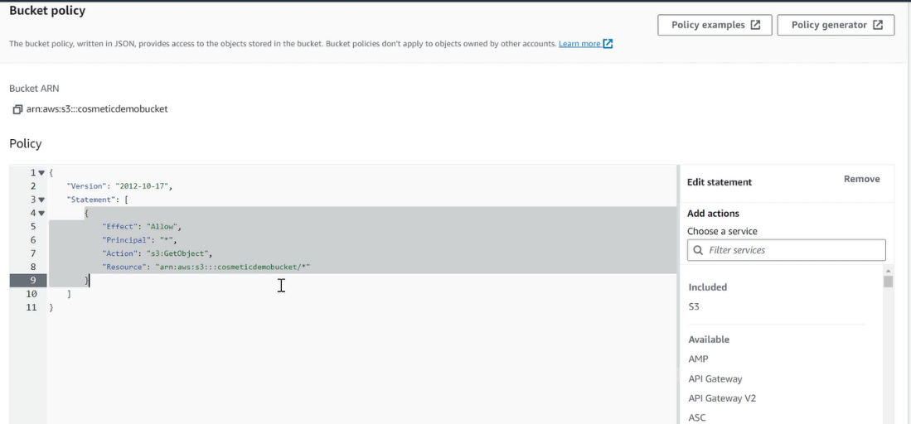

3. Upload image files to bucket

Click on the bucket, navigate to Object tab and click Upload

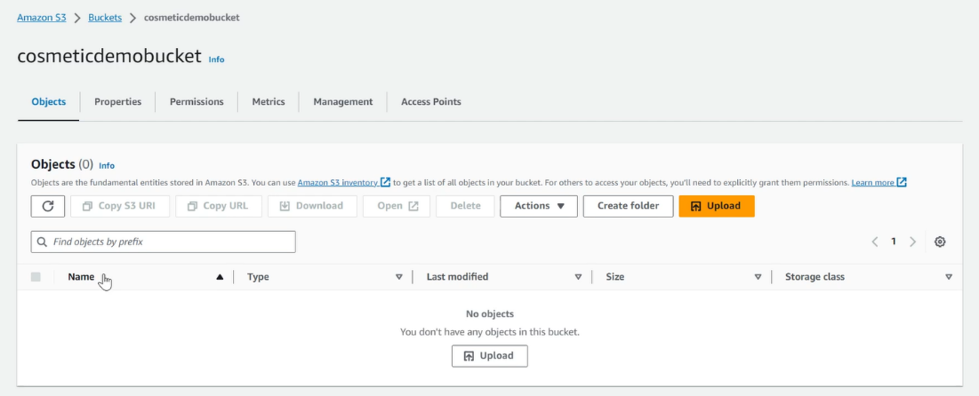

Click add file/folder, choose files/folders from your computer and click Upload.

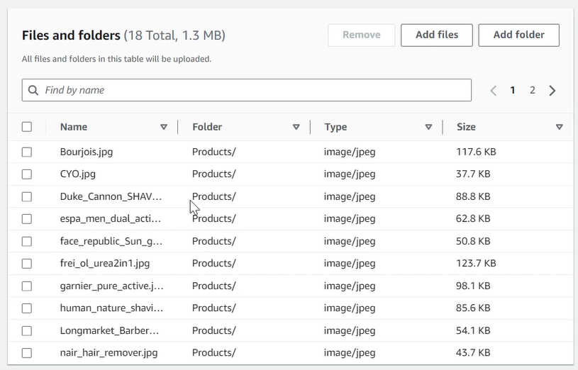

Wait for S3 to upload these files.

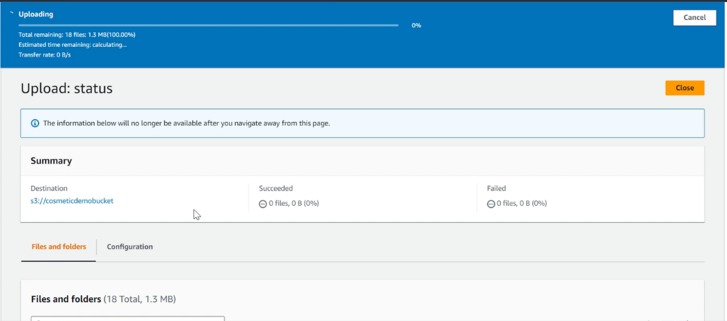

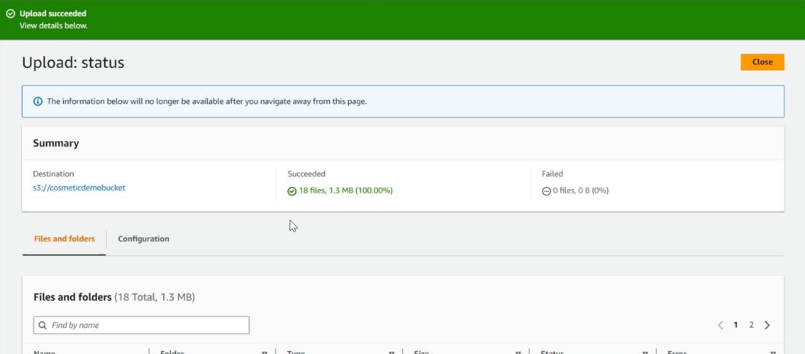

4. Checking

After uploading files/folders, click on the bucket and click the files/folders just created.

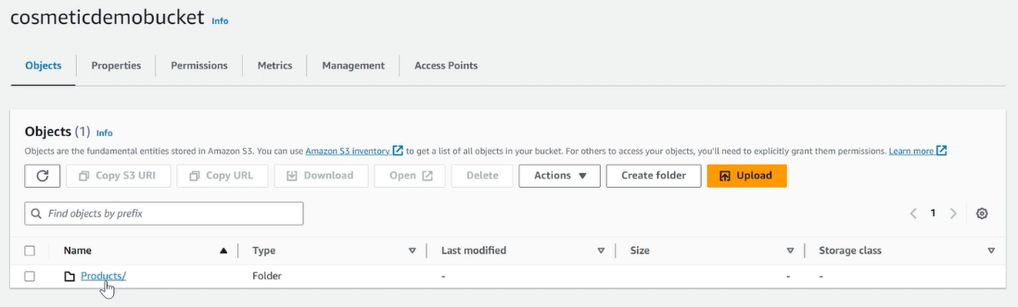

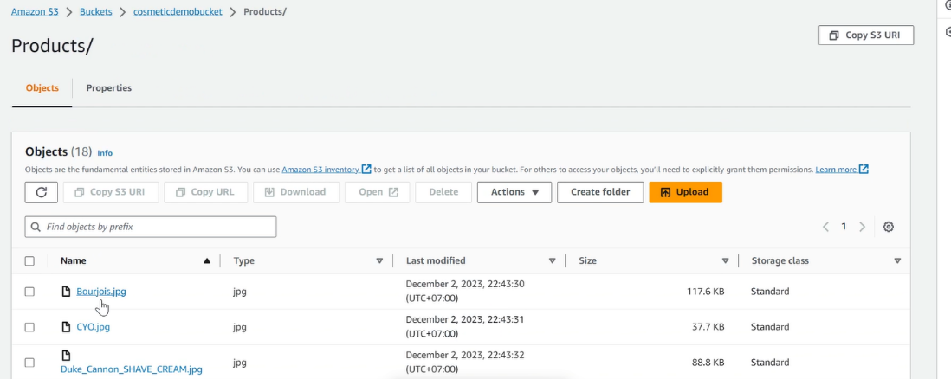

Click on the link in Object URL

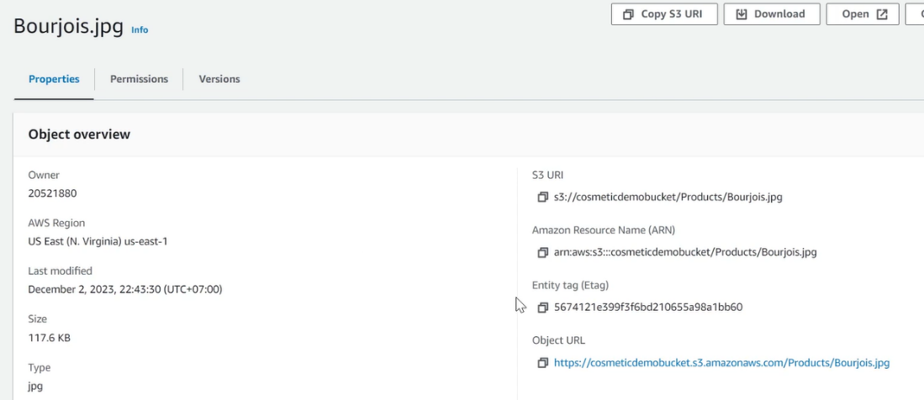

Result after click the URL:



1. DynamoDB
2. Go to the DynamoDB console and lick “Create table”

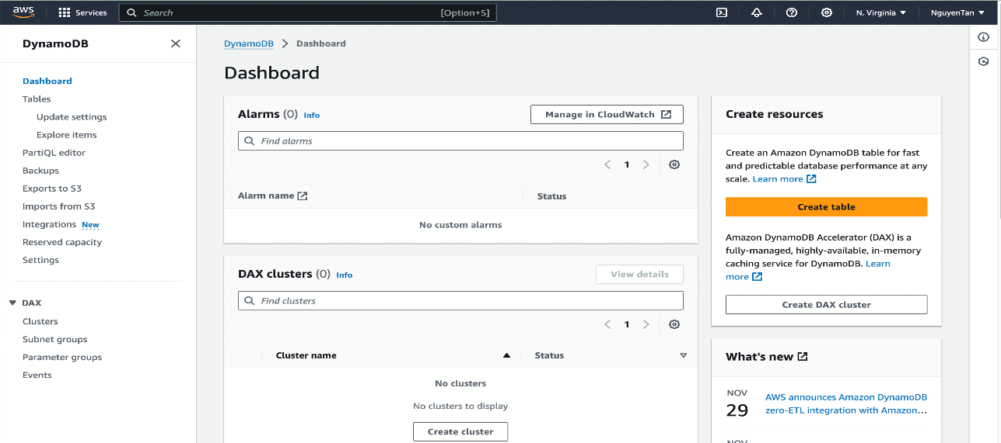

1. Enter table name and partition key ( primary key )

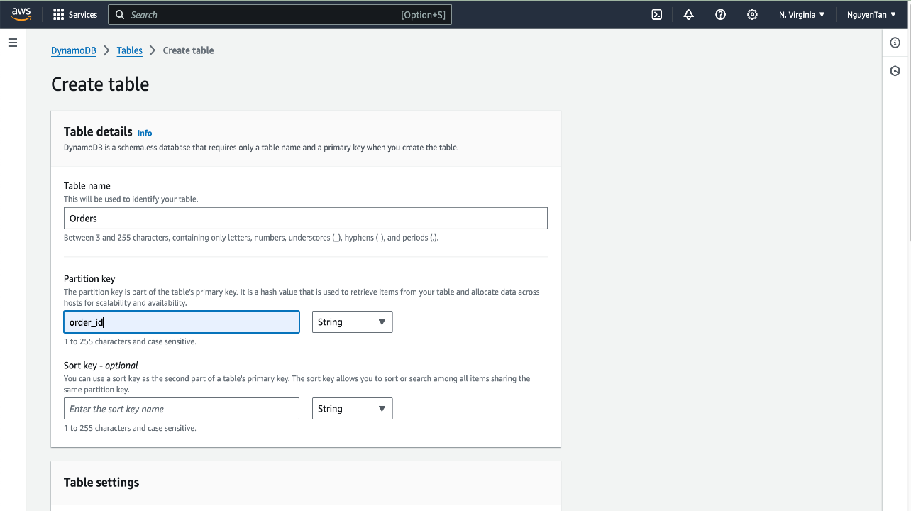

1. Choose default setting and click ‘create table’

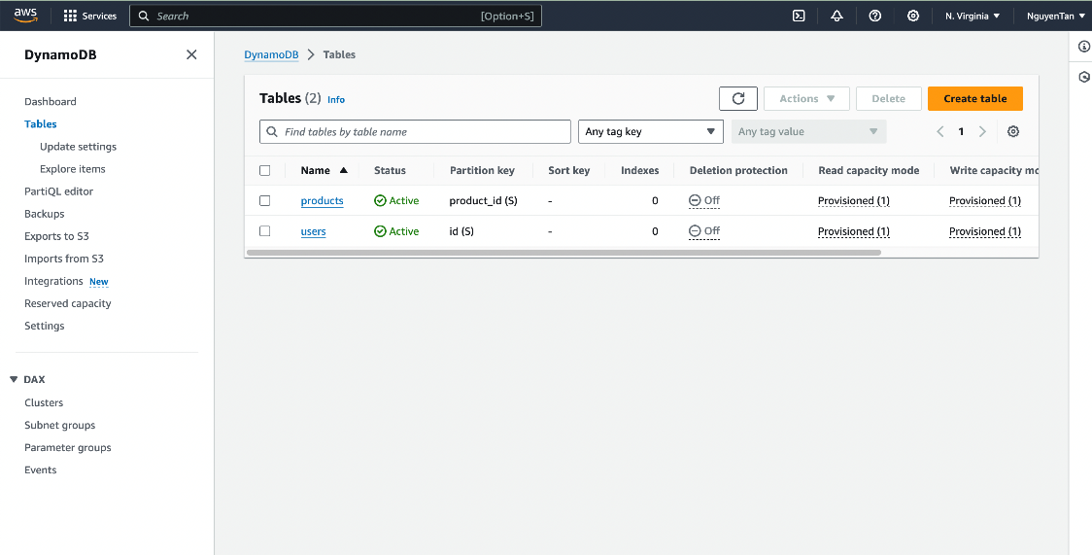

1. Click on Security Credentials to create access key.

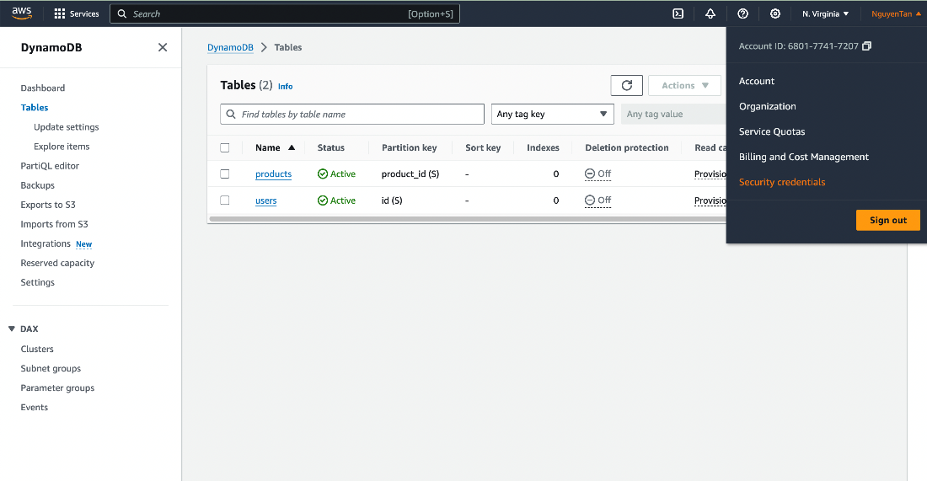

1. Click on Create Access Key

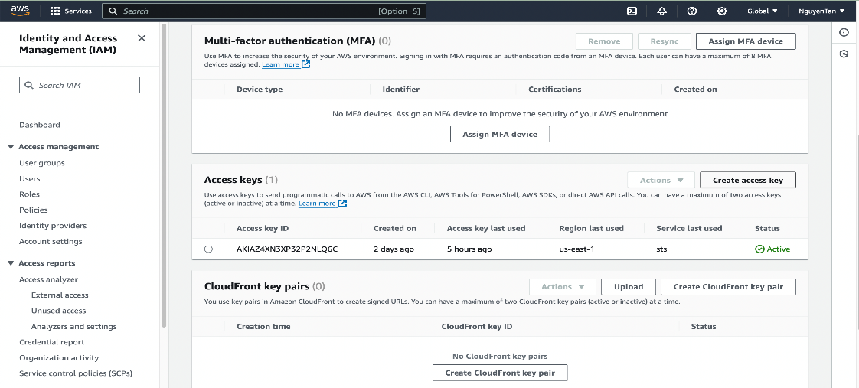

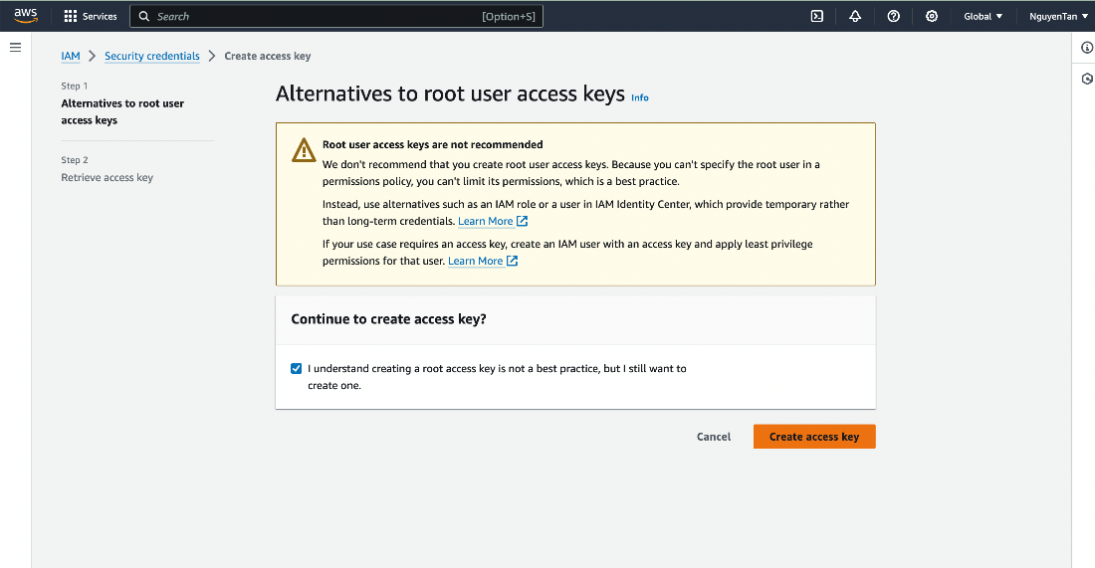

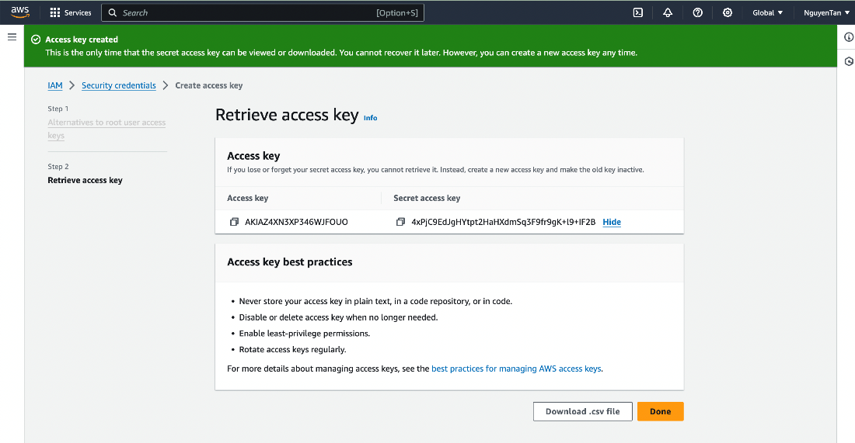

1. Connect DynamoDB with server. Enter access and secret access key just created on DynamoDB.

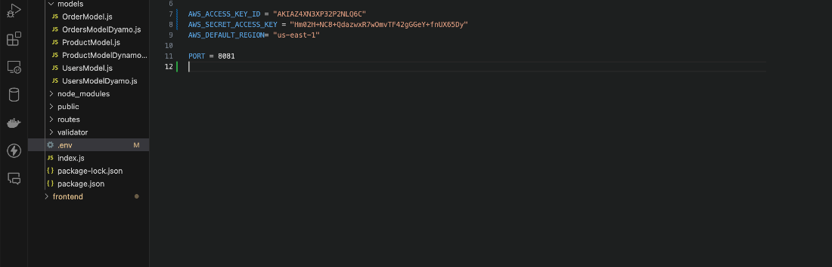

1. KMS
   1. Create key

Go to KMS console, navigate to Customer managed keys, then click Create key.

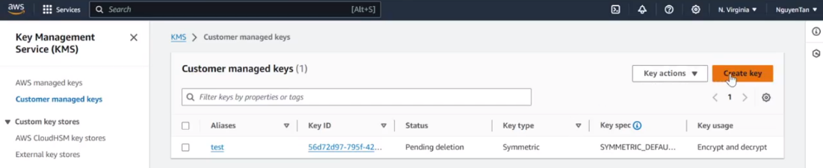

In Step 1 Configure key,

* Choose Symmetric as key type since DynamoDB use Symmetric key.
* Choose encrypt and decrypt as key usage.

After that, click Next

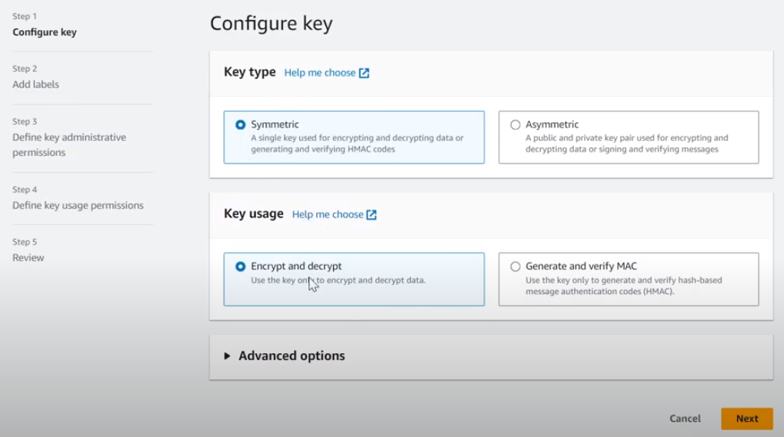

In Step 2 Add labels,

* + Enter alias (key name).
  + Add description and tag (optional).

After that, click Next.

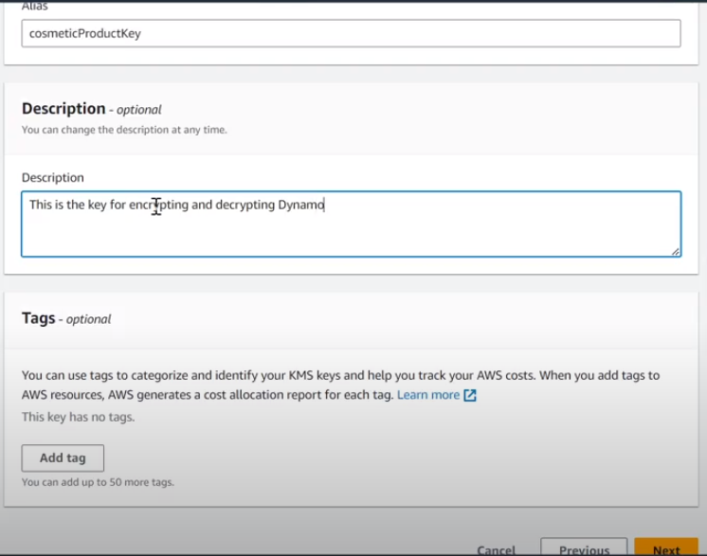

In Step 3 Define key administrative permissions,

* + Choose someone/something to give them key administrators.
  + Tick on the option “Allow key administrators to delete this key”

After that, click Next.

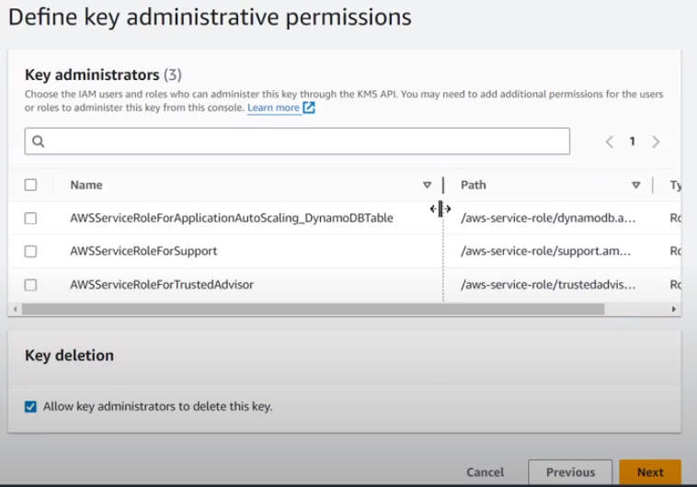

In step 4 Define key usage permission, tick on the one that is Dynamo service.

After that, click Next.

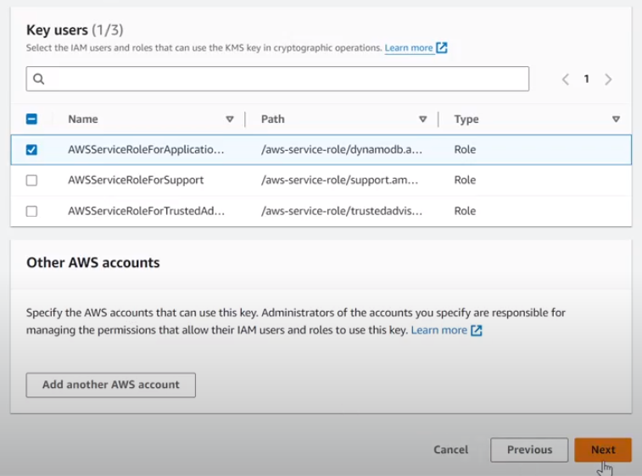

In Step 5 Review, click Finish.

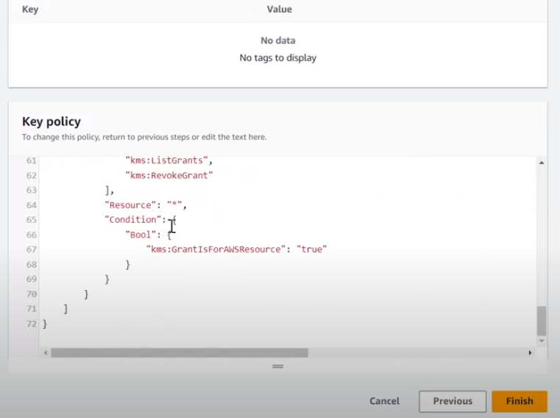

2. Add key to DynamoDB

Go to DynamoDB console, click on the table you want to use the key.

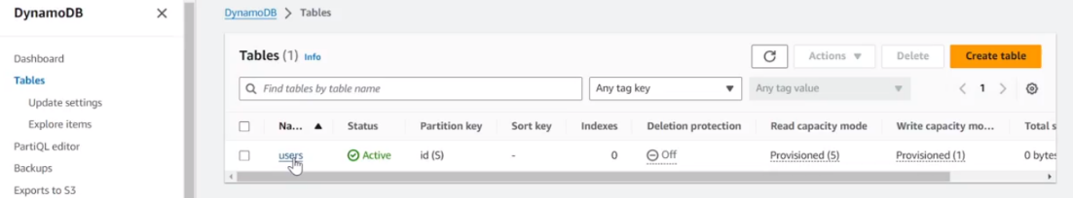

In the table console, navigate to Additional settings. 

In Additional settings, scroll down to Encryption, then click Manage encryption.

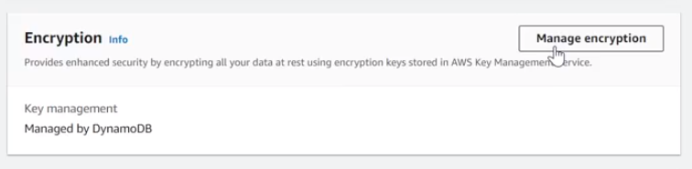

In Manage encryption console, choose Stored in your account, and owned and managed by you, then select the key just created.

After that, click Save changes.

